Master copy

Constitution
of the Cwmdare Voices ‘ODA’ male voice choir

Index
1/ Name of Choir
2/ Objectives of Choir
3/ Membership
4/ Code of conduct and attire
5/ Complaints procedure
6/ Disciplinary procedure
7/ Rehearsals
8/ Management Committee
9/ Areas of responsibility for officers
10/ Committee powers
11/ Committee meetings
12/ Annual general meeting
13/ Special General Meetings
14/ Quorums
15/ Voting
16/ Finance
17/ Musical team
18/ Health and Safety
19/ Data Protection
20/ Non membership roles
21/ Alterations to the constitution
22/ Dissolution
Appendix 1 Safeguarding adults policy
Appendix 2 Equality and Diversity policy
Appendix 3 Booking protocol
Appendix 4 Privacy Notice

1/ Name
The name of the Choir shall be Cwmdare Voices ODA and will be specifically a male only choir. Hereafter referred to as the Choir.
2/ Objectives
The Object of the Choir shall be:-
* To learn and perform songs and to strive for excellence in that endeavour.
* To encourage the goodwill and involvement of the wider community.
* To promote community wellbeing.
* To promote the advancement of local musical talent either through a monetary bursary or other support that may be deemed appropriate by the Management Committee.
* To provide a social outlet for the choir members.
* To promote inclusivity and the safeguarding of the members.
* To perform publicly for the purpose of entertainment and education.
* To organise, promote and perform in order to raise funds for charity and choir purposes.
* To promote choral singing to the general public through concerts and other events.
* To promote the growth of the Welsh language by learning and performing songs in Welsh.
* To establish and maintain regular practice sessions.
* To be a non-profit organisation.

3/ Membership

- Membership shall be open to anyone who has an interest in assisting the Choir to achieve its aim and is willing to adhere to the rules and policies of the Choir.
- Membership of the Choir shall be inclusive and open to all irrespective of age or physical impairment. (As a male voice choir the singing membership will be restricted to male gender only) (ref: Equality and Diversity Policy in appendix 2).
- The Choir shall be committed to equality in all its functioning, both within the choir and in its wider dealings with the public. It will actively seek to act and campaign against discrimination on the grounds of sex, sexual orientation or gender identity, age race, nationality, ethnic heritage or cultural origin, disability, religion, belief or any other aspect of identity which may lead to discrimination.
- For practical reasons and logistics the Choir should be limited to a maximum number of members which will from time to time be decided by the Management Committee.
- Where it is considered membership would be detrimental to the aims of the Choir, the Management Committee shall have the power to refuse membership, or may terminate or suspend the membership of any member by any resolution passed at a Committee meeting. Members shall have the right to appeal via an independent adjudicator acceptable to both parties.
- Any member of the Choir may resign his membership at any time by informing the Secretary in writing.
- Members would be required to pay a regular monetary subscription.
- Members will be expected to attend a majority of rehearsals.
- All members shall have the right to vote at any Annual General Meeting or special general meeting.
- The management committee shall have the right to suspend or defer any members contributions (not affecting that members rights to remaining a full Choir member) if that member is absent through illness or any other reason that may preventing him attending the day to day proceedings of the Choir

4/ Members code of conduct and attire:
Each member of the Choir shall conduct himself in keeping with expected standards laid down by the Management Committee and Musical Director. The Committee reserve the right to deal appropriately with any member conducting himself in a manner prejudicial to the effective running of the Choir.
Members shall attire in accordance with the dress code laid down by the Management Committee and will adhere to the instructions on dress for each performance or function.
The Choirs ‘number one’ dress will consist of a black dinner jacket, black trousers, a black dickie bow, white long sleeved shirt and black shoes and socks. A ‘number two’ dress code for less formal occasions may be employed as dictated by the Management Committee.
Members are requested not to be under the influence of drink or drugs at any rehearsal or performance. Any member not adhering to this policy will not be allowed to participate.

5/ Complaints procedure
All complaints are taken seriously, and should be communicated verbally or in writing to the Chairperson or a member of the Management Committee.
Any complaints will normally be dealt with at a regular committee meeting however; if the complaint is considered to be of a serious nature then an ad-hoc committee meeting may be convened specifically to deal with that complaint.
Persons involved in the complaint may be asked to attend such a meeting
The Management Committee’s decision will be final.

6/Disciplinary Procedure
The Disciplinary Procedure applies to all forms of misconduct, and is based on the following principles: to ensure a safe and appropriate environment; to be simple and transparent; and to be fair and impartial.
Informal discussions: Before taking formal disciplinary action, the management committee member or the Chairperson will make every effort to resolve the matter by informal discussions with the member concerned. Only where this fails to bring about the desired improvement should the formal disciplinary procedure be implemented.
Written warning: If informal discussions do not resolve the issue, and conduct or performance remains unsatisfactory, the member will be given a written warning from the Chairman, setting out the allegation and the basis for it. The member will be informed that termination of membership may be considered if there is no sustained satisfactory improvement or change.
Termination of membership: If there is no improvement, or a further offence occurs, the Management Committee may, by unanimous vote, terminate membership, subject to the member’s right to be heard by the Management Committee, accompanied by a friend if desired, before a final decision is made. For matters of serious misconduct the Management Committee may, at their discretion, go directly to any stage of the Disciplinary Procedures, or invoke a period of suspension pending investigation. This will depend upon the nature and level of misconduct. On termination of membership, the membership fee will be refunded pro rata.

7/ Rehearsal:

The Choir will normally meet for rehearsals on Tuesday evenings. The session will normally start at 7pm and finish at 9pm. The choir will normally meet at the Cwmdare Miners Welfare Club however, the venue and rehearsal times may be altered or be subject to change at the discretion of the Management Committee.

8/ Management Committee

- The Choir shall be administered by a Management Committee of no less than four (4) persons (referred to as the officers) and nominally six (6) committee members. This number may be increased as and when required by a general committee vote. Committee members must be at least 18 years of age. Members will be elected for a period of one year, but may be re-elected at the Annual General Meeting.
- Committee members may resign their post at any time by informing the Secretary in writing.
- The Committee will consist of:
The Chairperson
The Vice Chairperson
The secretary
The Treasurer
Committee members
Plus any additional officers the Choir deems necessary in order to carry out the required activities
- The management committee shall have the right to assemble or convene any subcommittee consisting of committee members and/or the general choir to carry out any project or task pertinent to the choirs advancement or function.

9/ Areas of responsibility of Officers:

Chairperson
The role of the chairperson is an honorary position appointed from the membership of the choir. The Chairperson should be of good standing, be prepared to promote the interests of the choir and shall be the official ‘spokesperson’ of the choir. He shall present to the members any relevant information deemed necessary for the day to day operation of the choir.
He will preside at all committee meetings (or sub meetings where required), direct members through agendas at meetings and also maintain good order within the proceedings. He will oversee the democratic decision making of the Choir and will also encourage the active participation of everyone in the day to day running of the choir.
Where there is an equality of votes, whether on a show of hands or on a poll the chairman at the meeting at which the show of hands takes place or at which the poll is demanded shall be entitled to a casting vote in addition to any other vote he/she may have.
Vice Chairperson
The Vice chairperson is an honorary position appointed from the membership of the choir. He will be empowered to undertake any of the roles and responsibilities of the Chairperson when the Chairperson is absent.

Secretary:
The role of the Secretary is an honorary position appointed from the membership of the choir. The duty of the Secretary is to be a point of contact for the public and to write and receive communications on behalf of the Choir. He will be responsible for notifying committee members of dates and times of meetings and providing agendas for those meetings. He will record in a written or other acceptable format all minutes arising from committee meetings. He will be responsible for presenting the minutes in a legible format at preceding meetings and for keeping copies, signed and dated by the Chairperson, for perusal by any member, at any time, should they be so required.
The Secretary will be responsible for, or for delegating, the production and distribution of information bulletins, song sheets etc. which should be presented to the members in a practical format.

Treasurer:
The role of the Treasurer is an honorary position appointed from the membership of the choir. It is his responsibility to keep all choir accounts up to date and in good order; to pay and receive invoices promptly and to form good, professional relationships with funders and external organisations.
He will be required to carry out duties in accordance with the financial requirements laid down in this document.

10/ Committee Powers

In furtherance of the objectives, but not otherwise, the Committee may exercise the power to:-
- Promote the wellbeing of the Choir members in order to work together irrespective of age, ethnicity, religion or political views.
- Provide a means whereby the members will be encouraged to acquire knowledge of music, singing and performing.
- Invite and receive contributions, raise funds where appropriate and investigate and apply for grant aid, to finance the work of the choir, and to open and maintain a bank account to manage such funds.
- To set members financial contributions and record each amount in a set record book (or other means as deemed appropriate)
- Promote the work of the Choir with organised practice sessions, instruction and performances.
- Engage staff and/or volunteers (who shall not be members of the management Committee) as are necessary to conduct activities to meet the Choir’s objectives. (i.e Musical director, accompanist, etc.)
- Take any form of action that is lawful, which may be deemed necessary to achieve the objectives of the Choir.
- To fill any vacant committee positions with responsible choir member/s as and when required.
- To ensure that appropriate insurances are in place to cover all aspects of the Choir’s undertakings.
- To take up membership of choir associations in order to promote, inform and keep abreast of developments within the wider communities of choirs.
- To undertake purchases of equipment essential to the function of the Choir.
- To deal effectively with comments, proposals, criticisms, complaints and suggestions and to take appropriate action to ensure they be resolved.

11/ Committee Meetings
- The Committee shall meet on a monthly basis (or at any other time that is deemed necessary) in order to discuss actions, monitor progress, consider future developments and debate any other proceedings relevant to the effective management of the Choir
- All Committee members shall be given at least 14 days’ notice of when a meeting is due to take place, unless it is deemed an emergency
- Fifty percent of Committee members must be present in order for a meeting to take place
- It shall be the responsibility of the Chairperson to ‘chair’ all meetings or a designated deputy in his absence.
- Minutes (records of proceedings) must be taken at all meetings and those minutes must be made accessible to all interested parties.

12/ Annual General Meeting

- An Annual General Meeting (AGM) shall take place every 12 months, usually in June of each year (or as arranged by the committee) and shall be held no later than 3 months after the end of the financial year. At least 14 days’ notice must be given to Choir members before an AGM takes place.
- The management committee will prepare an agenda for the AGM which will be posted (i.e notice board, email, etc) a minimum of fourteen days prior to the meeting and only items contained in that agenda will be discussed. Members wishing to raise a matter for inclusion at the AGM must submit a request in writing to the Secretary at least fourteen days before the meeting for it to be placed on the meeting’s agenda.
- All members are entitled to vote at the AGM. Voting shall be made by a show of hands on a majority basis. In the case of a tied vote the Chairperson (or Deputy) shall make the final decision.
- Nomination of Officers: Members may be nominated for any committee post at an AGM. The nominee shall apply in writing a minimum of 14 days prior to the AGM. The application for post shall contain the post of office for which the nominee wishes to stand and be countersigned by both a proposer and seconder who shall be current members of the Choir
In the event of more than one person being nominated for a single post, a vote will be taken by all members present including the presiding officers and choir members. A returning officer will be nominated by those present to conduct the vote and a simple majority will determine the outcome.

13/ Special General Meeting

Special General Meetings may be convened at the discretion of the Chairperson or on written application by three members of the general committee or by five members of the Choir, stating the reason for their request. Only the matter for which the meeting has been called will be discussed.

14/ Quorums
A quorum required for the AGM and any special general meeting shall be 50% of the voting membership. The quorum for management committee meetings shall be four members.
15/ Voting
From time to time the Choir membership may be required to undertake a vote on a specified issue or matter. The subject of the issue or matter and the reason for such a vote should be fully explained and communicated to the membership prior to such a vote taking place. This may be undertaken either verbally by the Chairman or a nominated Committee member, or in writing (including the Choir WhatsApp facility, letter or other social media means). All efforts, when practicable, shall be made to pre-inform the membership of any vote that is scheduled to take place.
The vote may generally be taken by a show of hands (from time to time and at the Committees discretion other means of voting may also be employed) and a quorum of 50% of the Choir membership (Which includes Committee members) should be present at any vote. The result of the vote will be carried by a majority (in excess of 50%) of those present. Proxy votes may be accepted and included only if submitted in writing prior to the vote taking place.
Where there is an equality of votes, whether on a show of hands or on a poll the Chairman at the meeting at which the show of hands takes place or at which the poll is demanded shall be entitled to a casting vote in addition to any other vote he/she may have.

16/ Finance
A membership subscription shall be established. The amount, frequency and method of subscription shall be set by the Management Committee and may be changed by a majority vote at a quorate Committee meeting as and if circumstances dictate.
- The Committee may agree to suspend a members financial contribution if that member is absent through ill health or other unavoidable circumstance.
- Any money acquired by the Choir, including donations, contributions, bequests and grants shall be paid into an account/s operated by the Management Committee in the name of the Choir.
- All funds must be applied to the objectives of the Choir and for no other purpose.
- A bank account shall be opened and maintained in the name of the Choir. The Treasurer will be responsible for the day to day administration of the account.
- Any cheques relating to the Choir’s bank account shall be signed by at least two (2) of the following Committee Members; Chairperson, Secretary, Treasurer.
- Any income/expenditure shall be the responsibility of the Treasurer who will be accountable to ensure any funds are recorded effectively and that the account stays within budget.
- Official accounts will be maintained by the Treasurer and a balance report presented at each Committee meeting. An annual financial report will be presented to the members at the AGM.
- The Choirs accounting year will run from the 1st of April to 31st March each year and will be subject to an examination by an independent auditor/accountant who is not a member of the Management Committee.
- When a member has left or resigned from the Choir for any reason and has stopped paying a subscription they will forgo any claims to any benefits accumulated either through Choir subscriptions or other means during their time as a member

17/ Musical Team:
Music Director
The music director shall be appointed by the Management Committee and be responsible for both the musical direction of the choir and the delivery of the programme of musical content. He/she shall be appointed for their musical ability, professionalism in music and choral production, their ability to instruct and manage and their ability to undertake their role in organising stage presentation and performance management.
The Musical Director will be paid a remuneration for rehearsals, performances and any other functions as agreed by the management Committee. The amount of remuneration will be set by the Management Committee and may be changed at the discretion of that Committee in agreement with the MD as circumstances dictate.
The Music Director will consult with the Management Committee on any subject relating to the Choirs music content or organisational management of performances. The protocol for making arrangements for concerts/performances are laid out in appendix 3
The MD may from time to time appoint, with the agreement of the Management Committee, a deputy director. Any remuneration for the deputy will be agreed by the management Committee
Accompanist:
The musical accompanist (pianist) shall be appointed jointly by the Management Committee and Music Director and be responsible for the playing of the piano at rehearsals and performances as directed.
The accompanist will be paid remuneration for rehearsals, performances and any other functions as agreed by the management Committee. The amount of remuneration will be set by the Management Committee and may be changed at the discretion of that Committee as circumstances dictate.
The Committee in conjunction with the Musical Director will be responsible to appoint a ‘stand-in’ accompanist as and when necessary and set any remuneration required

18/ Health and Safety
Members have a duty of care for themselves and others affected by their actions. Members will be notified of any H&S issues at a performance and advised accordingly.
The Management Committee will not be held liable for any injury or mishap that may occur from not complying with the given instructions.
A safeguarding policy is attached to this document under Appendix 1

19/ Data Protection (Ref: Privacy notice appendix 4)
The Committee will keep records of data relating to individual members and patrons. This data will normally include the person’s name, address, telephone numbers, and email addresses; however, occasionally other details may be requested and retained, such as passport numbers when booking transport for overseas events. Photographs of choir groups and individual choir members may also be kept on file and may, with the individual members consent, be used for publicity purposes or for advertising the choir in any promotional literature or computer based sites. Additionally, chorister’s names may occasionally be shared with third parties when, for example, booking hotel rooms etc. Any personal information held by the committee shall be held in a secure manner and will not be shared with any other person/organisation without the individual’s express sanction. Storage and usage of personal data held by the choir shall be subject to, and conform to the requirements laid down in the General Data Protection Regulations (GDPR)
20/ Presidents, Patrons and other non-membership roles.
The Management Committee may from time to time appoint a president whose role will be to ‘figure head’ the Choir at functions as circumstances dictate. Ambassadors/Honorary Patrons may also be selected from the wider community whose role would be to promote and endorse the Choir and its purpose.
The choir has a policy to establish a list of patrons from the wider community. These patrons will be expected to pay a yearly financial subscription and as a ‘Patron Member’ will be entitled to attend a yearly choir performance as well as be considered for priority tickets for choir performances.
21/ Alterations to the Constitution
Any changes to this constitution must be agreed by a majority vote at an Annual General Meeting or at a special general meeting convened specifically for that purpose.
22/ Dissolution
The Choir may be dissolved if agreed by the members in a majority vote at a special meeting. Any assets or remaining funds after debts have been paid shall be transferred to local charities or similar groups at the discretion of the Management Committee.

Signed Chairperson
Secretary
Treasurer,
Member
Member

PAGE 1 Appendix 1
CWMDARE VOICES ‘ODA’ SAFEGUARDING ADULT POLICY
Cwmdare Voices
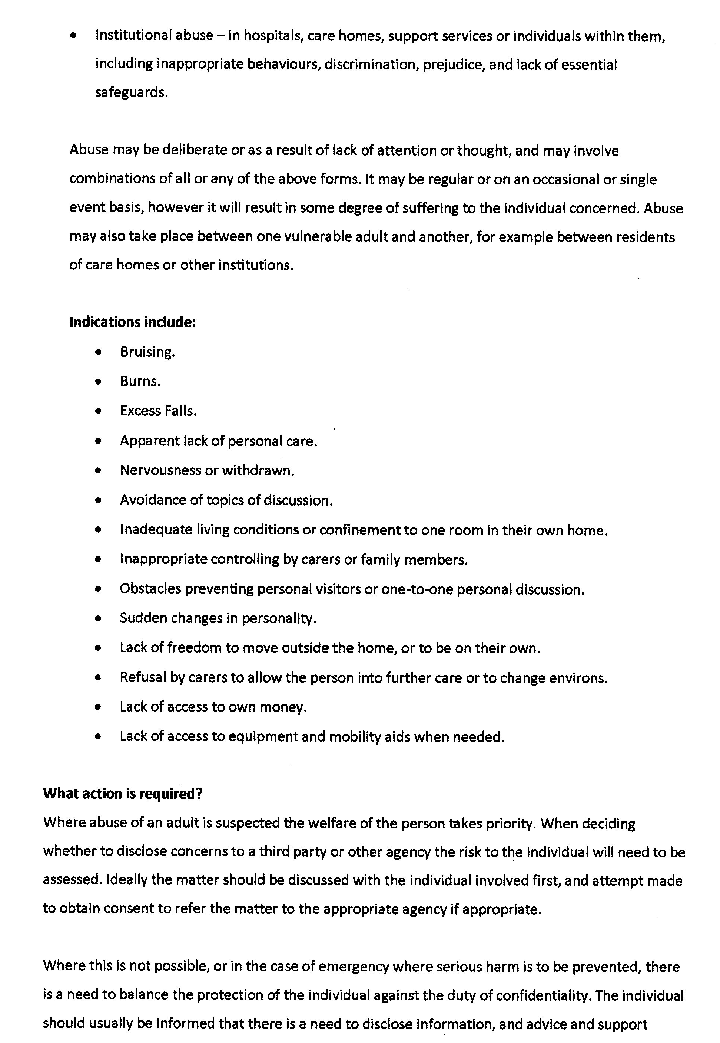

Who’s who for safeguarding vulnerable adults?

Social Care
Social Services local Tel No. 01685 88800
Adult Services….. (Community Resource Team) Tel: 01443 425003 (Mon – Fri, 9am – 5pm) Emergency contact Tel: 01443 743665
Rhondda Cynon Taff County Borough Council
Police
Cross St., Aberdare. Tel: 0745132650
Non emergency 101
In an emergency
If vulnerable adult is potentially injured ring 999
If someone is threatening to harm the vulnerable adult ring 999

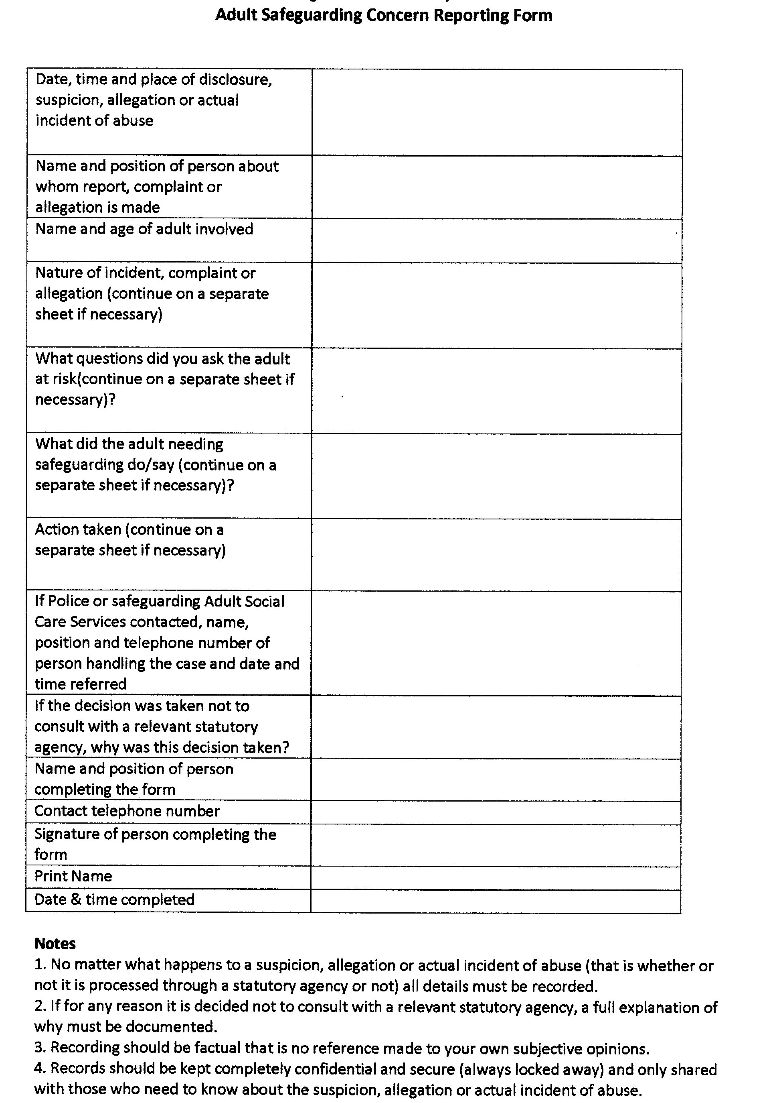

Cwmdare Voices ODA Appendix2

Appendix 2
Equality and Diversity policy

1. Context

1.1 This policy is intended to demonstrate the commitment of Cwmdare Voices Choir to eliminating discrimination and encouraging and valuing diversity among choristers staff, volunteers, and partners,

1.2 We recognise our responsibilities under the Equality Act 2010 (appendix), and are committed to meeting them in full. We believe that a culture that embraces equality and values diversity will help us to ensure that everyone feels involved and included in our plans, programmes and activities.

1.3 We aim to create an environment which respects and welcomes everyone, and in which no form of bullying, harassment, disrespectful or discriminatory behaviour is tolerated by anyone towards anyone. This particularly applies in relation to the ‘protected characteristics’ named in the Equality Act 2010:
Age, disability, gender reassignment, income, marriage or civil partnership status, pregnancy and maternity, race, religion or belief, sex and sexual orientation.

2. Our responsibilities

2.1 Cwmdare Voices Choir understands that for equality to be achieved this policy needs to be made understandable to, and embraced by all members.
The policy is fully supported and welcomed by all choristers and has been agreed by our Committee.
2.2 The members, suppliers, partners have a responsibility to ensure that their own language and actions are consistent with the spirit as well as the contents of this policy.

2.3 Overall responsibility for the implementation of this policy lies with Cwmdare Voices Choir Committee.

3. Our commitments

3.1 Cwmdare Voices Choir recognises that an Equality and Diversity Policy alone is not enough to ensure that equality and diversity are central to everything that we do.

3.2 We will seek to create an environment in which diversity and the contributions of all staff, volunteers, suppliers, partners, and trustees are recognised and valued in all that we do.

3.3 In introducing this policy we recognise that many people are unfamiliar with the ways in which discrimination and disadvantage affect people’s health, well-being and quality of life. We will therefore support people to develop equalities awareness and understanding.

3.4 To ensure that we are meeting the aims and the spirit of this policy we will:
Discuss and review how well we are implementing this policy, and adjust our practices where necessary;
Assess any significant new or revised policies and procedures for their impact on equality;
Embed equality and diversity into our development plans;
Ensure our employment practices and procedures are consistent with the aims of this policy.

4. Working with other organisations and partners
It is important to us that any other individual or organisation working on behalf of the Choir are aware of and agree to comply with our equality and diversity policy while that work is underway. In addition we are committed to:
Using accessible venues for rehearsals, events and meetings;
Using plain English and accessible communications as far as it is within our means to do so, for example, emails, letters, reports social media and publicity materials.

5. Review and Action

5.1 We recognise that it is important for us to regularly review this policy to ensure that it reflects up to date equality legislation and best practice.
5.2 A review of our Equality and Diversity Policy will be carried out on a 3 yearly basis as a minimum and any necessary actions taken if required.

Appendix 3
Concert Booking Protocol

- It is appreciated that enquiries and requests made for the choir to perform may come from a variety of sources and members are encouraged to actively seek these opportunities. If the opportunity arises please obtain contact details.

- All enquiries/requests must initially be directed to the Choir Secretary.

- The Choir secretary will liaise with the organisation/individual making the enquiry/ request to establish the following details.
The date and time of the performance
The venue
The involvement of performance required i.e. part of a concert, a charity fund raiser etc.
Contact details
(Finance should not be raised at this point)

- The Choir Secretary will contact both the Musical Director and accompanist to ensure their availability

- The Choir Secretary will notify the Chairperson and other committee members, either at a committee meeting or by other means of communication if time is of an essence.

- The Chairperson will address the choir members at the first opportunity in order to ensure sufficient availability. Usually by a show of hands.

- An appointed person will be responsible to produce a paper list and record the names of those available.

- The Committee together with the MD will consider the logistics of the event and discuss finances. If a charge is to be levied then this should be established at this point.

- The Choir Secretary will contact the enquirer to confirm the booking, establish further relevant details and discuss financial arrangements.

- An appointed person shall be responsible for arranging any transport requirements including booking coaches if required.

- The Chairperson will report the booking confirmation and travel arrangements to the choir members at the earliest opportunity.

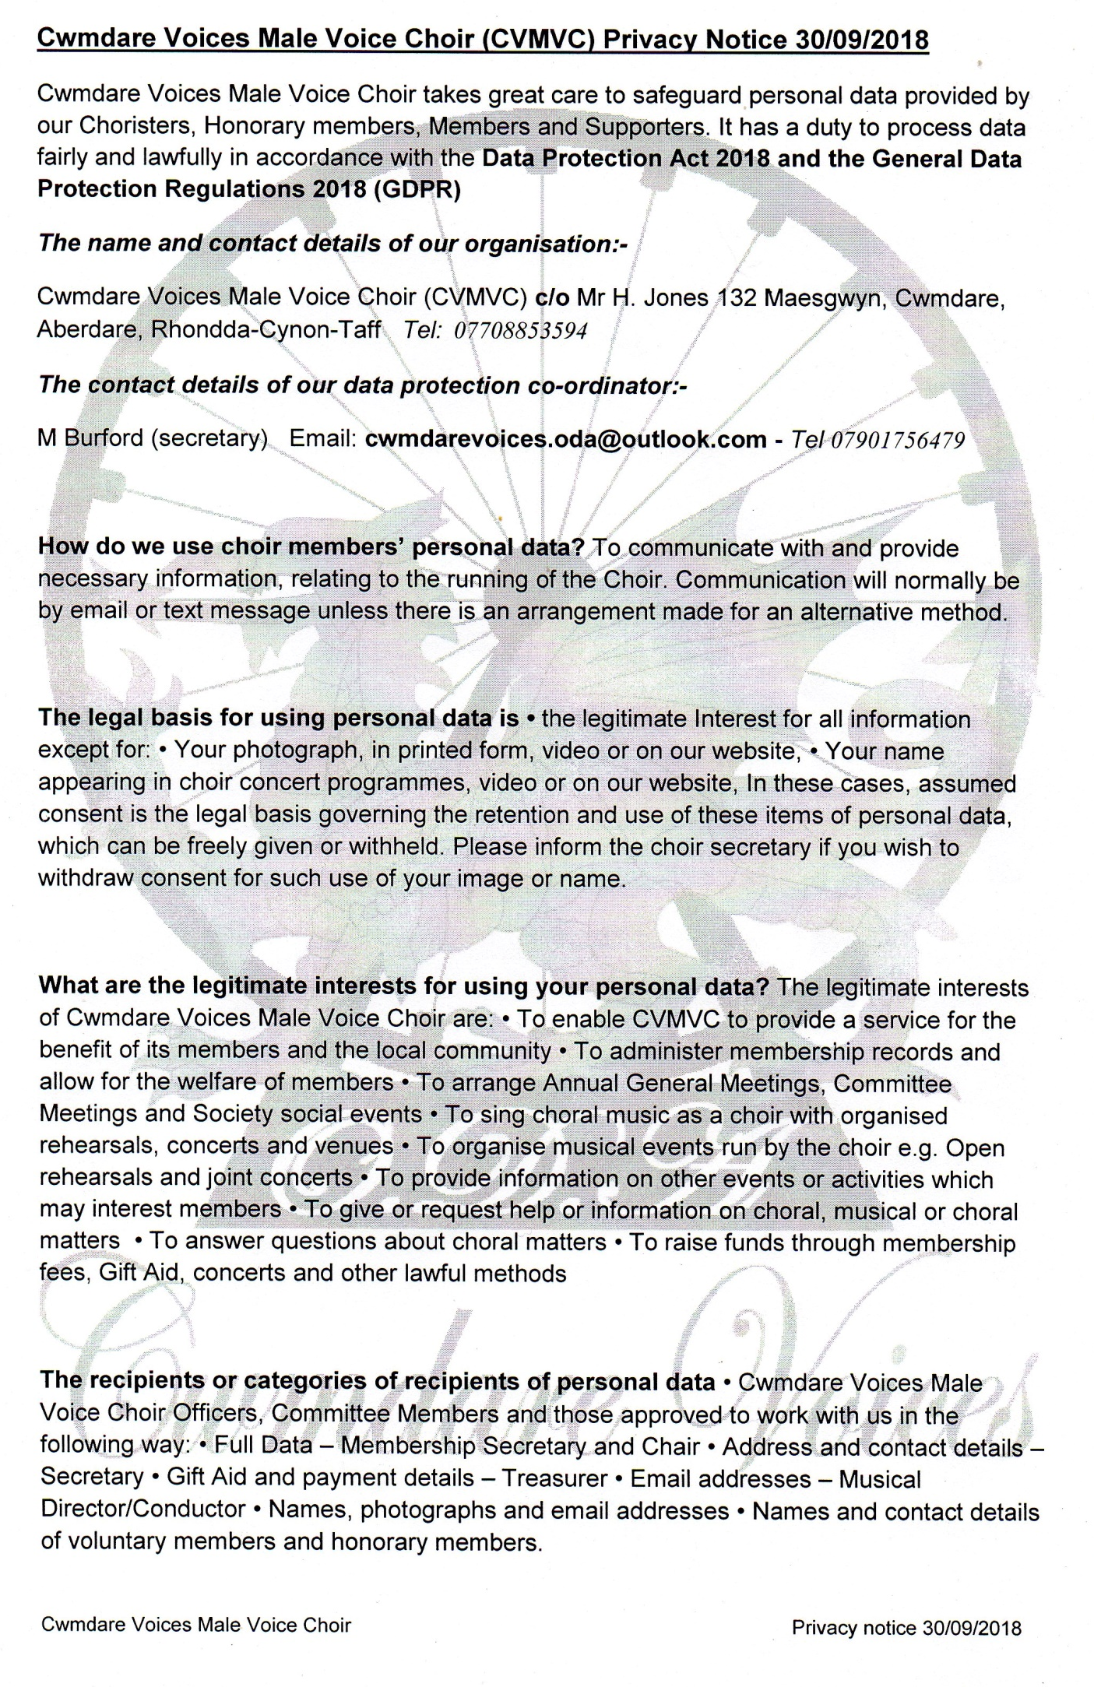
RCT, CF44 7HF Tel: 07794525773 Email demann@hotmail.co.uk
David Manning, Lower Mardy Lodge,
APPENDIX 4

